One Day Course in Practical Mining

Course Date: 16th April 2019
Time: 09:00 – 16:30
Location: Geological Survey of Ireland, Beggars Bush, Dublin

Instructors Brendan Morris - Chartered Mining Engineer, Managing Director LTMS
Kevin Lonergan - Chartered Mining Engineer, Operations Director, LTMS
Padraig Barrett - Mining Engineer, Technical Director, LTMS

Course Description
The one-day course on Practical Mining is an overview of mining, designed to give geoscience professionals, such as geologists, geotechnical engineers, environmentalists and planners an understanding of the mining process from the exploration stage to mine closure.

The course is made up of a series of modules, progressing through the process, delivered via Powerpoint presentations and short videos. The course is delivered by up to three Directors of LTMS
- Lisheen Technical and Mining Services, all of whom are Mining Engineers.

Objectives
The outcome provides the attendees with an understanding of the whole mining process so that decisions relating to mining at any stage, such as pre-mine planning, mine operations, mine closure or aftercare can be made in a more informed way.

Modules
Introduction to Mining Ore Reserve Statements
Mine Safety Mining Methods
Development Mining Production Mining
Mine Geology Drilling & Blasting
Geotechnical Engineering Ventilation
Mine Equipment Mine Economics
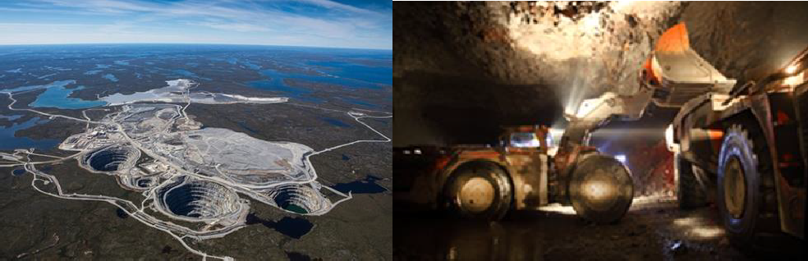
Mine Environment and Closure

