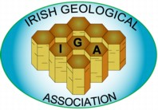

**Lecture Title: “Geology within the National Museum of Ireland”**

**Nigel Monaghan (Retired Keeper of Natural History at NMI)**

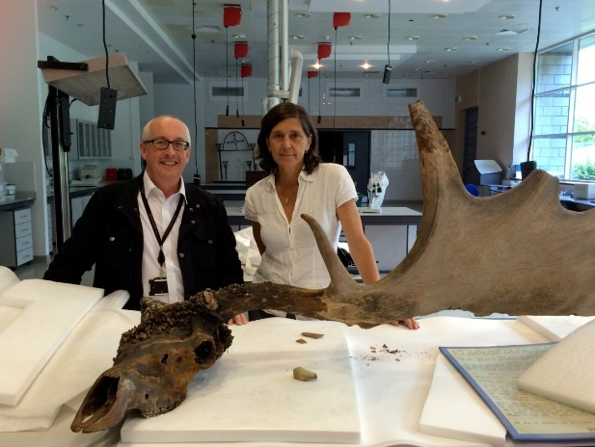 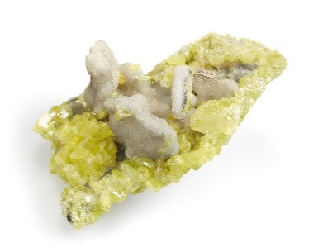 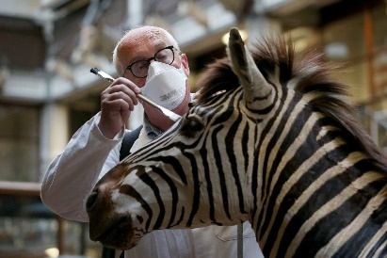 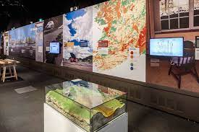

The National Museum is well known for the Dead Zoo on Merrion Street in Dublin, but this is primarily a zoology gallery and their rich geological collections are much less well known. The earliest collections are from the 1786 mineral survey of the Dublin Society, who started a museum in earnest with a major German mineral collection in 1792.

A succession of Professors managed the museum and built up the collections to the point that a full-time curator was able to open the purpose built building we know today. Beside the zoological museum, there were galleries for geology and botany lost in the 1960s-1970s. The museum became a state body in 1877, with significant funding from a rich empire and the curators shopped till they dropped. Few geologists in Ireland today will be aware of the sabre-toothed cat skeleton, the 7-metre pliosaur, 30 ichthyosaurs, or extensive mineral collections not on view.

These specimens, and many more, will feature during this very special lecture.

**Nigel Monaghan** was the Geology Curator (1981-2001) and Keeper of Natural History (2001-2022) in the National Museum of Ireland

**Venue:** This will be a hybrid lecture **in person at the M4 Lecture Theatre, Department of Geology, Trinity College Dublin and on Zoom**

**Gathering from 7pm**

To **Register** for this lecture, in person or online, please do so [HERE](https://forms.gle/AX6cveRdhkpwWMx78)

Many thanks to Prof. Jerry Dickens, Prof. David Chew and staff at Geology, TCD for their work in facilitating this IGA event



**Extraordinary General Meeting of the Irish Geological Association**

**on 4th December 2024 at 7.20 pm**

**Venue: M4 Lecture Theatre, Museum Building, Trinity College Dublin and on Zoom**

There are two items on the Agenda for this EGM, as agreed at our AGM on 24th April 2024

1. Election of Treasurer on the Council of IGA 2024/2025 – Mr. Michael Shorten has been proposed to take over this role from Mr. Daniel O’Shea
2. Election of Auditor for the IGA’s Accounts